**Demand for labour**

***Author****:* [*Geoff Riley*](http://www.tutor2u.net/blog/index.php/site/author/3/)***Last updated:*** *Sunday 23 September, 2012*

**Introduction**

**Labour Demand – Marginal Revenue Product**

* How many people should a business look to employ?
* Theories of the demand for labour try to analyse links between the demand for labour and a variety of economic factors. We start with the marginal revenue productivity theory of the demand for labour.

**Marginal Revenue Product** (MRPL) measures the change in total revenue for a firm from selling the output produced by additional workers.

**MRPL = Marginal Physical Product x Price of Output per unit**

* Marginal physical product is the change in output resulting from adding an extra worker.
* The price of output is determined in the product market – in other words, the price that a business can get in the market for the goods and services that they have produced.

A numerical example of marginal revenue product is shown in the next table:

|  |  |  |  |  |  |
| --- | --- | --- | --- | --- | --- |
| **Labour** people employed | **Capital (K)**  Units of capital | **Total Output** (Q) units | **Marginal Product**  Units | **Price per unit of output when sold (£)** | **Marginal revenue product = MPP x P (£)** |
| 0 | 5 | 0 | / | 5 | / |
| 1 | 5 | 30 | 30 | 5 | 150 |
| 2 | 5 | 70 | 40 | 5 | 200 |
| 3 | 5 | 120 | 50 | 5 | 250 |
| 4 | 5 | 180 | 60 | 5 | 300 |
| 5 | 5 | 270 | 90 | 5 | 450 |
| 6 | 5 | 330 | 60 | 5 | 300 |
| 7 | 5 | 370 | 40 | 5 | 200 |
| 8 | 5 | 400 | 30 | 5 | 150 |
| 9 | 5 | 420 | 20 | 5 | 100 |
| 10 | 5 | 430 | 10 | 5 | 50 |

* We are assuming in this example that the firm is operating in a perfectly competitive market such that the demand curve for finished output is perfectly elastic at £5 per unit.
* Marginal revenue product follows directly the behaviour of marginal physical product. Initially as more workers are added to a fixed amount of capital, the marginal product is assumed to rise.
* However beyond the 5th worker employed, extra units of labour lead to **diminishing returns**. As marginal physical product falls, so too does marginal revenue product. For example the 5th worker taken on adds $450 to total revenue whereas the 9th worker employed generates just £100 of extra income.

The story is different if the firm is operating in an imperfectly competitive market where the demand curve is downward sloping. In the next numerical example we see that as output increases, the firm may have to accept a lower price per unit for the product it is selling. This has an impact on the marginal revenue product of employing extra units of labour. One again though, a combination of diminishing returns to extra labour and a falling price per unit causes marginal revenue product (eventually) to decline. In our example below, it starts to fall once the 7th worker is employed.

|  |  |  |  |  |  |
| --- | --- | --- | --- | --- | --- |
| **Labour** | **Capital (K)** | **Output (Q)** | **MPP** | **Price (£)** | **MRP = MPP x P (£)** |
| 0 | 5 | 0 |  | 10.0 |  |
| 1 | 5 | 25 | 25 | 9.60 | 240 |
| 2 | 5 | 60 | 35 | 9.00 | 315 |
| 3 | 5 | 100 | 40 | 8.70 | 348 |
| 4 | 5 | 150 | 50 | 8.20 | 410 |
| 5 | 5 | 210 | 60 | 7.90 | 474 |
| 6 | 5 | 280 | 70 | 7.70 | 539 |
| 7 | 5 | 360 | 80 | 7.00 | 560 |
| 8 | 5 | 430 | 70 | 6.80 | 476 |
| 9 | 5 | 450 | 20 | 6.50 | 130 |
| 10 | 5 | 460 | 10 | 6.00 | 60 |

MRP theory suggests that **wage differentials** result in part from variations in the level of **labour productivity** and also the value of the output that the labour input produces.   
The main assumptions of the marginal revenue productivity theory of the demand for labour are:

* Workers are **homogeneous** in terms of their ability and productivity (clearly unrealistic!)
* Firms have **no buying power** when demanding workers (they have no monopsony power.)
* **Trade unions** have no impact on the labour supply (the possible impact on unions on wage determination is considered in later chapters.)
* The **physical productivity of each worker** can be accurately and objectively measured and the market value of the output produced by the labour force can also be calculated.
* The **industry supply of labour** is assumed to be perfectly elastic. Workers are occupationally and geographically mobile and can be hired at a constant wage rate. This means that the marginal cost of taking on extra workers is assumed to be constant.

**The profit maximising level of employment**   
Now we consider how many people a business might decide to employ. The profit maximising level of employment occurs when a firm hires workers up to the point where the **marginal cost of employing an extra worker** equals the **marginal revenue product of labour**. I.e. MCL = MRPL.   
This is shown in the labour demand diagram shown below.

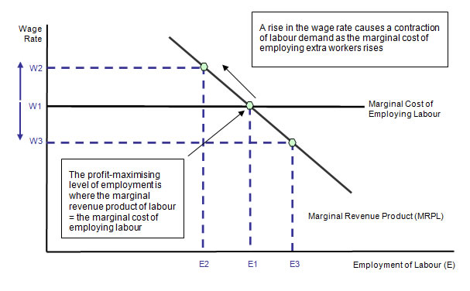

**Limitations of MRPL theory of labour demand**

1. **Measuring productivity**: Often it is hard to measure productivity because no physical output is produced or the output may not be sold at a market price. This makes it tough to place a true valuation on the output of each extra worker. How does one go about valuing the final output of people employed in teaching, social care or the armed forces? It is easier to measure output in industries where a tangible product is produced each day.
2. **Pay Award Bodies:** In some jobs wages and salaries are set independently of the state of labour demand and supply. Over five million public sector workers for example fire-fighters, pharmacists, council workers, nurses and teachers have their pay set according to decisions of independent pay review bodies with “market forces” having only an indirect role in setting pay-rates.
3. **Self employment and Directors’ Pay:** There are over three million people classified as self-employed in Britain. How many of these people set their wages according to the marginal revenue product of what they produce? And what of those people who have the ability to set their own pay rates as directors or owners of companies? Recently we have had fierce debates about the huge level of bonus payments paid to city workers many of whom were behind the risk-taking that contributed towards the credit crunch. Was their pay justified on the grounds of marginal revenue product? How does one go about measuring the marginal revenue product of people working in complex financial markets?

**Shifts in the Demand for Labour**

The number of people employed at each wage level can change and in the diagram below we see an outward shift of the labour demand curve. The curve shifts when there is a change in the conditions of demand in the jobs market. For example:

* A change in **demand** for a product which means that a business needs to take on fewer workers
* A change in the **productivity of labour**
* A change in the level of **national insurance contributions** made by employers or other costs of employing people such as health and safety legislation and training levies
* A change in cost and productivity of machinery and technology which might be able to produce or provide a good or service in place of the labour input.

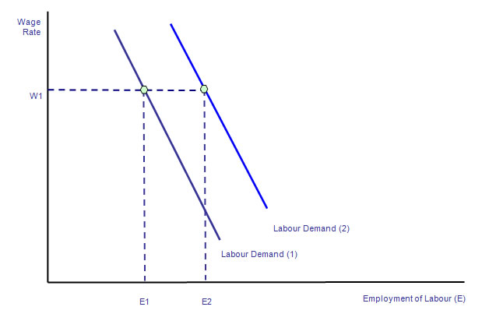

**Labour as a Derived Demand**

* The demand for labour is a **derived demand** i.e. the demand depends on the demand for the products they produce.
* When the economy is expanding, we expect to see a rise in the **aggregate demand for labour** providing that the rise in output is greater than the increase in labour productivity.
* In contrast, during a recession or a slowdown, the aggregate demand for labour will decline as businesses look to cut their operations costs and scale back on production.

In a recession, business failures, plant shut downs and short-term redundancies lead to a reduction in the derived demand for labour. The construction industry is an example of the **derived demand for labour**. The decade long property boom in the UK has led to rising prices, output and employment but since 2008 the property market has been in recession leading to many thousands of job losses.

**Case Study: Pay Cuts in a Recession**

The recession is having a huge effect on the UK labour market. Unemployment is rising at a very fast rate; the number of unfilled vacancies has dropped. And the total number of people in a job either full time or part time is now on the slide. How best should business respond to the recession in terms of the pay and conditions they offer to their employees.

Pay cuts and pay freezes are being flagged up as an increasingly common option by businesses struggling to survive. Staffs working for the publisher Penguin who earn over £30,000 have had their salaries frozen. Premiership rugby clubs in Britain have agreed to freeze their salary cap at £4m. And a new survey from the British Chambers of Commerce covering 300 member firms found that 43% plan to freeze wages and salaries in the coming year. Nearly one business in ten will go a step further and attempt to cut basic pay and salaries – a measure almost unprecedented in the experience of today’s workers.”

There are many broader economic effects of a situation in which wage packets and salaries are either held constant or cut.

* ***Pension incomes:***
  + A series of pay cuts this year and next may affect the value of pensions of people who are on final salary schemes. This will be fiercely resisted by trade unions - especially those representing workers in the state sector
* ***Productivity and efficiency***:
  + Will reductions in pay lead to lower productivity? Pay cuts of 10 per cent or a freeze on wages (which amounts to a cut in real pay) could have a negative effect on worker morale.
* ***Equity***
  + Will pay cuts be across the board from executive level through to shop floor workers?
* ***Impact on consumer demand:***
  + Will a squeeze on real take-home incomes lead to an even deeper cut in consumer spending - aggravating the extent of the recession in the domestic economy? Many businesses will be using a mixture of layoffs, reduced hours, less overtime and wage freezes - all of which have a negative effect on average earnings

An inward shift of labour demand ought to bring about a reduction in the real value of wages and salaries in a competitive labour market. But wage freezes or cuts are not yet common across most industries. Some employers are trying more imaginative ways to reduce their payroll expenses. Some have offered their workers longer holidays or sabbaticals on a fraction on their annual pay. Others have slashed the amount of overtime available. Many employers recognise that - having strained hard to recruit their best workers - it would be foolish and counter-productive to get rid of them in a recession, whose duration few are confident in predicting.

**Elasticity of Demand for Labour**

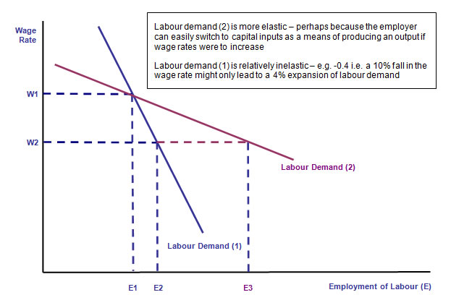

Elasticity of labour demand measures the **responsiveness** of demand for labour when there is a change in the wage rate. The elasticity of demand for labour depends on:

1. **Labour costs as a % of total costs**: When labour expenses are a high proportion of total costs, then labour demand tends to be elastic. In many service jobs such as call-centres, labour costs are a high proportion of the total costs of a business.
2. **The ease and cost of factor substitution**: Labour demand will be more elastic when a firm can substitute quickly and easily between labour and capital inputs. When specialised labour or capital is needed, then the demand for labour will be more inelastic. For example it might be fairly easy and cheap to replace security guards with cameras but a hotel would find it almost impossible to replace hotel cleaning staff with machinery!

**The price elasticity of demand for the final output produced by a business**: If a firm is operating in a competitive market where final demand for the product is price elastic, they may have little market power to pass on higher wage costs to consumers.