**Determination of wages in the labour market**

***Author****:* [*Geoff Riley*](http://www.tutor2u.net/blog/index.php/site/author/3/)***Last updated:*** *Sunday 23 September, 2012*

**Equilibrium wages and wage differentials**

There is a wide gulf in pay and earnings rates between different occupations in the UK [labour market](http://www.tutor2u.net/blog/index.php/economics/C151/). Even in local labour markets there will be variations in pay levels – for example, in London bus drivers working for different companies can see differences in pay of up to £6,000 a year?

In 2010, chief executives of FTSE-100 companies were paid on average 145 times the average salary. Back in 1999 the multiple was 69. On current trends it will be 214 by 2020, or around £8m a year.

In the 30 years to 1979, the share of income going to the top 0.1 per cent of earners dropped from 3.5 per cent to 1.3 per cent. Today, the top 0.1 per cent takes home as big a share as it did in the 1940s.

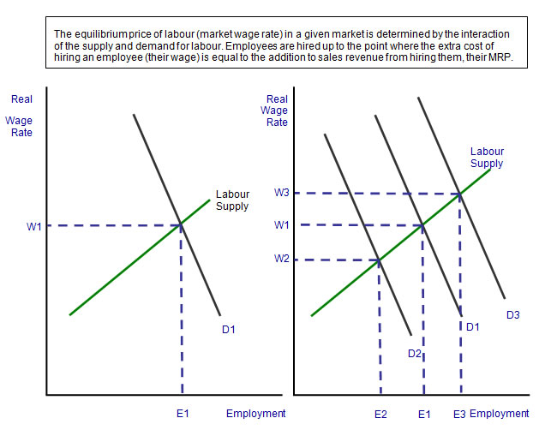

[**Wage Differentials**](http://www.tutor2u.net/blog/index.php/economics/tagged/tag/wage+differentials/)

No one factor explains the gulf in pay that persists between occupations:

1. **Compensating wage differentials** - higher pay can often be reward for **risk-taking** in certain jobs, working in poor conditions and having to work **unsocial hours.**
2. **Equalising difference and human capital** - in a competitive labour market, wage differentials compensate workers for the opportunity costs and direct costs of human capital acquisition.
3. **Different skill levels** - the gap between poorly skilled and highly skilled workers gets wider each year. Market demand for skilled labour grows more quickly than for semi-skilled workers. This pushes up pay levels. Highly skilled workers are often in inelastic supply and rising demand forces up the "**going wage rate**" in an industry.
4. **Differences in labour productivity and revenue creation** - workers whose efficiency is highest and ability to generate revenue for a firm should be rewarded with higher pay. E.g. sports stars can command top wages because of their potential to generate extra revenue from ticket sales and merchandising.
5. **Trade unions and their collective bargaining power** - unions might exercise their bargaining power to offset the power of an employer in a particular occupation and in doing so achieve a **mark-up** on wages compared to those on offer to non-union members
6. **Employer discrimination** is a factor that cannot be ignored despite equal pay legislation

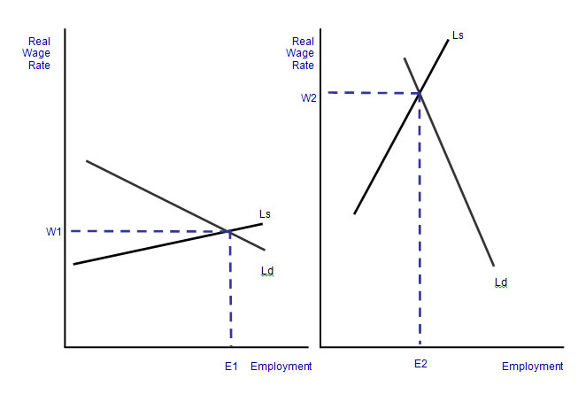

**Sticky wages in the labour market**

Economists often refer to the existence of **“sticky wages**.” In a fully flexible labour market, a decrease in the demand for labour should cause a fall in wages and a contraction in employment - just like any demand curve shifting down.

However, sticky wages refers to a situation in which the **real wage level doesn't fall immediately**, partly because many employees have **wages specified in employment contracts** that cannot be re-negotiated immediately, and because workers (perhaps protected by their trade unions) are resistant to cuts in nominal wages.

If the wage level cannot fall when demand falls, it leads to a much bigger drop in employment and, more importantly, **involuntary unemployment** because of a failure of the labour market to clear.

The evidence for sticky wages is a good counter-argument to neo-classical models of the labour market that suggest that real wage levels respond flexibly to any changes in labour demand and supply conditions.

Will wages become less sticky during the recession? There are signs that workers, fearful for their jobs at such a difficult time, have become more willing to consider and perhaps accept pay freezes or wage cuts traded off against improved job security.