**Labour force and government policy**

***Author****:* [*Geoff Riley*](http://www.tutor2u.net/blog/index.php/site/author/3/)***Last updated:*** *Sunday 23 September, 2012*

**Government policies and the labour supply**

The main policies designed to increase the supply of labour available to the economy are as follows:

**Reforms to the system of direct taxation:** In the 1980s, Thatcherite economics focused on cutting income tax rates particularly at the top end and switching from direct towards indirect taxation. More recently, governments have tended to focus more on reductions in the lower rates of income tax and tax allowances for lower-paid workers. The theoretical idea remains broadly the same, that lower direct taxes increase the post-tax reward to working and act as an incentive for more people to join the labour supply. In 2007 the government announced that the 10% starting rate of income tax would be withdrawn in 2008 and that the basic rate of tax would be cut from 22% to 20%. From 2010 the government plans to have a top rate of income tax of 50% for the highest income earners.

**Reforms to the benefits system:** The emphasis here has changed away from the rather crude idea of cutting the real and relative value of welfare benefits towards encourage people into searching for work, towards a reliance on tax credits (for example the Working Families Tax Credit) to give parents with children a greater financial incentives to work. The aim is to reduce the disincentive problems created by the unemployment and [poverty trap](http://www.tutor2u.net/blog/index.php/economics/tagged/tag/poverty+trap/).

**Increased investment in education and training**: This is designed to boost the **human capital** of the labour force and improve the **occupational mobility** of the labour force to meet the changing demands of employers across different industries.

**A more relaxed approach to labour immigration**: Particularly where there are shortages of workers with skills such as consultants and fully trained nurses in the NHS, or shortages of teachers in certain subjects. The effect of net inward migration on the labour supply is shown in the diagram below.

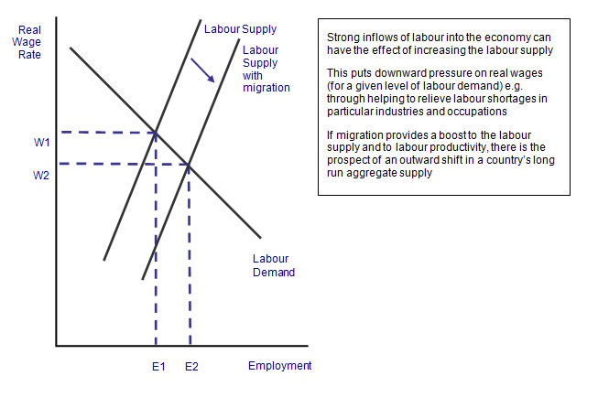

**The Work-Leisure Trade Off**

Will people work longer hours if they are offered higher pay?

Standard economic theory would suggest that the real wage is a key determinant of the number of hours. The real wage is the money wage rate adjusted for changes in the price level and it measures the quantity of goods and services that can be bought from each hour worked.

An increase in the real wage on offer in a job should lead to someone supplying more hours over a given period of time

There is the possibility that further increases in the wage rate might have little effect on an individual’s labour supply. Indeed, there is the possibility of a backward-bending individual labour supply curve. This is illustrated in the next diagram.

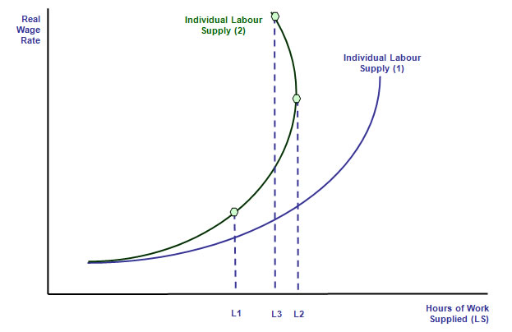

Two distinct individual labour supply curves are shown.

* In the first curve, higher real wages lead to an increase in the number of extra hours supplied, although the rate at which the individual gives up their leisure time and work longer hours diminishes as the real wage rises.
* In the second curve, for most of the range of real wages, the same prediction holds true, but when as real wages step upwards, eventually an individual may choose to actually work fewer hours (ceteris paribus) giving us what is sometimes termed a **“backward bending” labour supply curve.**

**Income and substitution effects**

To understand why this might happen we consider the income and substitution effects that arise from a change in the real wage being paid to an individual worker. We start with the income effect.

* **The income effect**: Higher real wages increase the income that someone can earn from a job, but they also mean that the hours of work needed to earn enough to pay for a product declines. Higher [pay](http://www.tutor2u.net/blog/index.php/economics/tagged/tag/pay/) levels mean that a target real wage can be achieved with fewer hours of labour supply. So this income effect might persuade people to work less hours and enjoy extended leisure time.
* **The substitution effect**: The substitution effect of a higher wage rate should unambiguously give people an incentive to work extra hours because the financial rewards of working are raised, and the opportunity cost of not working (measured by the wages given up when people opt for leisure instead) has increased.
* With the income and substitution effects working in opposite directions, there is no hard and fast prediction about whether people will choose to increase their labour supply as real wages increase.
* Are the income and substitution effects different for male compared to female workers?
* What about younger workers entering the labour market for the first time who are looking to save to finance a deposit on a house or to fund other major items of spending?
* How might people closer to retirement age respond to changes in real wages?
* What of workers in households where at least someone else is in paid employment compared to a household where there is only one main “breadwinner”?

**The importance of incentives**

* Most of us rely on income from our work to pay for the things we need and higher pay and better conditions should be an incentive perhaps to work some extra hours or search for work in the first place.
* But for many workers there are disincentives to supply their labour – and these problems often affect people in lowly paid jobs.

This is known as the problem of the [**poverty trap**](http://www.tutor2u.net/blog/index.php/economics/tagged/tag/poverty+trap/)