**Monopsony in the labour market**

***Author****:* [*Geoff Riley*](http://www.tutor2u.net/blog/index.php/site/author/3/)***Last updated:*** *Sunday 23 September, 2012*

With increasing frequency these days we read in the media of stories of people – often in low paid jobs – who claim that they are being underpaid for the job that they do. T

There are many possible reasons for this and one of them is the effect of an employer using their monopsony power. This is the focus of this revision note,

**Monopsony**

A [**monopsony**](http://www.tutor2u.net/blog/index.php/economics/tagged/tag/monopsony/) **producer** has **buying power in the labour market** when seeking to employ extra workers and may use that buying-power to **drive down wage rates**.

The monopsonist knows that they face an upward sloping labour supply curve, in other words, to attract more workers in their industry, they must [pay](http://www.tutor2u.net/blog/index.php/economics/tagged/tag/pay/) a higher wage rate – so the **average cost of employing labour** rises with the number of people taken on.

Because the average cost of labour is increasing, the **marginal cost of extra workers will be even higher**, since we assume that an increase in the wage rate paid to attract one extra worker must also be paid to existing workers.

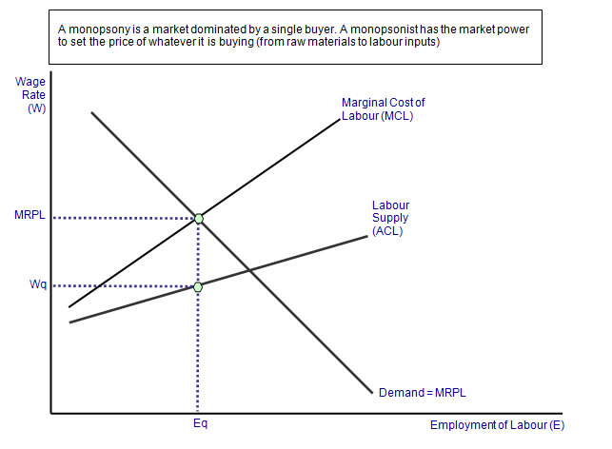

* The profit maximising level of employment is where the **marginal cost of labour equates with the marginal revenue product of employing extra workers**.
* In the diagram, Eq workers are taken on, but the monopsonist can employ these workers at an average wage rate of Wq – a pay level below the marginal revenue product of the last worker.
* In this sense, the monopsonist is exploiting labour by not paying them the full value of their marginal revenue product.
* **Trade unions** may seek to counter-balance the monopsony power of an employer by controlling aspects of the labour supply and by using whatever collective bargaining power they possess to negotiate wages higher without being at the expense of employment levels.

**Examples of monopsony employers**

* Major employers in a small town (e.g. a car plant, a major supermarket or the head office of a bank)
* Nursing homes as employers of care assistants.
* The government can also have monopsony power as the major employer in the teaching profession or the National Health Service
* Local authorities are also big employers for example in refuse collection, street-cleaning and in running council nursing homes and local libraries
* Agencies who employ thousands of people in the hotel, catering and cleaning industries
* The farming sector which employs huge numbers of people on temporary terms during the peak harvesting season

**Government intervention in labour markets to combat the effects of worker exploitation**

An employer having monopsony power in the labour market does not necessarily mean that workers will find their wages and other terms and conditions worse than if the market for labour was more competitive.   
That said there often are an economic and a clear social justification for legal interventions in the jobs market to provide support and backing for thousands of vulnerable and often poorly-paid people.  
Two examples of such intervention are

* Legal protections such as the Gangmasters Authority
* The national minimum wage (NMW) and also a campaign for a living wage. The London living wage was introduced in 2005 and more than 100 London-based employers have signed up to it.

**Gangmasters Licensing Authority (GLA)**

The Gangmasters Licensing Authority was set up in 2006 to combat exploitation of workers in agriculture, horticulture and food processing plants, by overseeing the people who supply much of the labour.  
In 2008 it set up operation Ajaz – an investigation into pay and working conditions in a cluster of industries where workers are thought to be most vulnerable to exploitation – it targeted employers in the agriculture, horticulture, forestry, shell fishing and food processing industries.

**The National Minimum Wage (NMW)**

The National Minimum Wage (NMW) is a minimum amount per hour that most workers in the UK are entitled to be paid. The NMW rates are reviewed each year by the Low Pay Commission and from 1 October 2011 the main hourly rate for workers aged 21 is £6.08 (£4.98 for workers aged 18-20, with lower rates for workers aged 16-17 (£3.68) and for apprentices under 19 years old £2.60).

**How might a minimum wage impact on employment and the wage decisions of a monopsony business?**

* Because the [minimum wage](http://www.tutor2u.net/blog/index.php/economics/tagged/tag/minimum+wage/) is a [**pay**](http://www.tutor2u.net/blog/index.php/economics/tagged/tag/pay/) **floor**, the monopsonist cannot pay a wage below it
* So the NMW effectively becomes the marginal and average cost curve for hiring workers up to employment level Emin.
* Thereafter to hire additional staff, the wage rate must be bid up, again creating a divergence between the average and marginal cost of labour.
* The effect on the diagram is that with an appropriately set rate, the profit maximising level of employment after a minimum wage is higher (E2) and the wage rate paid to labour has also increased (W2).
* In this example, making certain assumptions, a minimum wage might actually boost total employment and secure better pay for workers in occupations and industries where there is some monopsonistic power among the buyers of labour.

