**Supply of labour**

***Author****:* [*Geoff Riley*](http://www.tutor2u.net/blog/index.php/site/author/3/)***Last updated:*** *Sunday 23 September, 2012*

**Introduction**

**Labour Supply**

* The [**labour supply**](http://tutor2u.net/blog/index.php/economics/tagged/tag/labour+supply/) refers to the total number of hours that labour is **willing and able to supply** at a given wage rate.
* It is the number of workers willing and able to work in a particular job or industry for a given wage.
* The labour supply curve for an industry or occupation will be upward sloping.
* This is because, as wages rise, other workers enter this industry attracted by the incentive of higher rewards. They may have moved from other occupations or they may not have previously held a job, such as housewives or the unemployed.
* The extent to which a rise in the prevailing wage or salary in an occupation leads to an expansion in the supply of labour depends on the elasticity of labour supply.

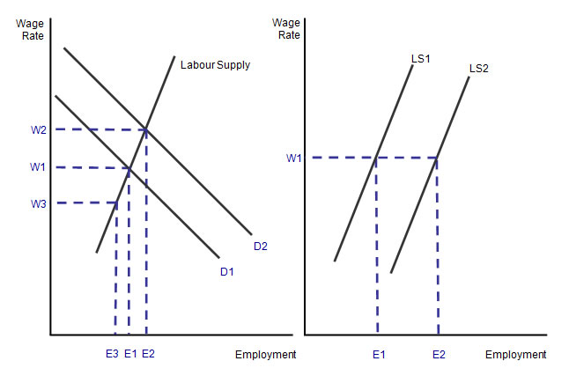

**Key factors affecting labour supply**

The supply of labour to a particular occupation is influenced by:

**The real wage rate on offer in the industry itself** – higher wages should boost the number of people willing and able to work.

**Overtime:** Opportunities to boost earnings come through overtime, productivity-related pay schemes, and share option schemes.

**Substitute occupations:** The real wage rate on offer in competing jobs is another factor because this affects the wage and earnings differential that exists between two or more occupations. So for example an increase in the relative earnings available to trained plumbers and electricians may cause some people to switch their jobs.

**Barriers to entry:** Artificial limits through the introduction of minimum entry requirements or other legal barriers to entry can restrict labour supply and force average pay levels higher e.g. legal services and medicine where there are strict “entry criteria” to the professions.

**Improvements in the occupational mobility of labour:** For example if more people are trained with the necessary [skills](http://www.tutor2u.net/blog/index.php/economics/tagged/tag/skills/) required to work in a particular occupation.

**Non-monetary characteristics of specific jobs** – include factors such as the level of risk, the requirement to work anti-social hours, **job security**, opportunities for promotion and the chance to live and work overseas, employer-provided in-work [training](http://www.tutor2u.net/blog/index.php/economics/tagged/tag/training/), subsidised health and leisure facilities and occupational pension schemes.

**Net migration of labour** – the UK is a member of the EU single market that enshrines free movement of labour as a guiding principle. A rising flow of people seeking work in the UK is making labour migration an important factor in determining the supply of labour available to many industries – be it to relieve shortages of skilled labour in the NHS or education, or to meet the seasonal demand for workers in agriculture and the construction industry. The recession has caused inward migration to slow down and in some cases to reverse.

**Elasticity of labour supply**

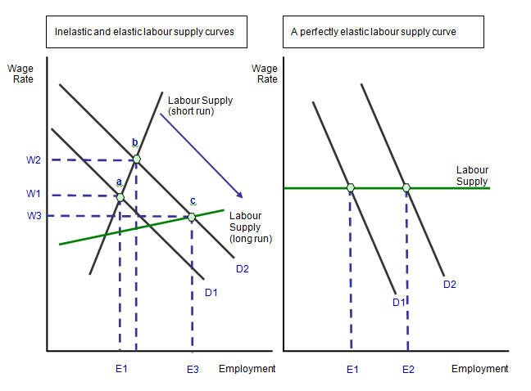

* The elasticity of labour supply to an occupation measures the extent to which labour supply responds to a change in the wage rate in a given time period.
* In lower-skilled occupations, labour supply is elastic because a pool of labour is employable at a fairly constant market wage rate.
* Where jobs require **specific skills** and **training**, the labour supply will be more inelastic because it is hard to expand the workforce in a short period of time when demand for workers has increased.