Topic 8) The Labour Market wage determination
Define the following key terms
Key term | Definition
Equilibrium wage rate

Wage differentials

Explain the following causes of wage differentials
Cause of wage differential | Explanation
Compensating

Equalising difference and human capital

Different skill level

Productivity

Trade unions and collective bargaining power

Discrimination

Explain the following key terms
Key term | Explanation
Trade Union

Collective bargaining

Explain why trade union power has fallen in recent years

Use the axis to draw a diagram to help you explain why a trade union is likely to be more effective when the demand for labour in wage inelastic as opposed to wage elastic (p131)
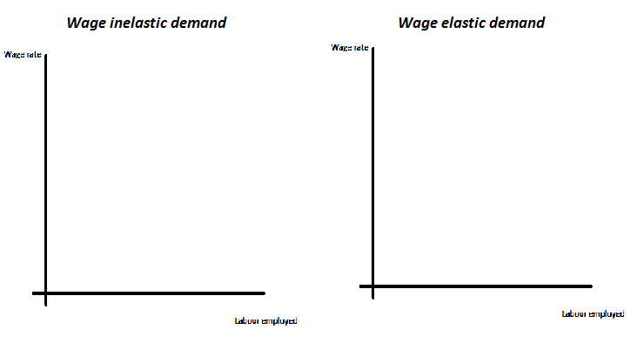
Explanation

Explain the term ‘monopsony’ and outline a range of examples of monopsony employers

Use the diagram below to explain the wage rate and employment level offered by a monopsony (profit maximising employment)
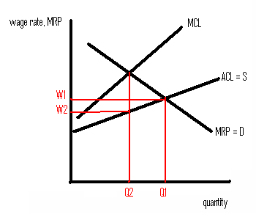
Explanation

On your diagram add an additional line which shows the impact that a national minimum wage may make on a monopsony employer

Explain the term ‘discriminiation’

Below shows a labour D & S diagram. MRPL = D1 shows the demand for female ethnic minorities and MRPL = D2 shows the demand for male white people
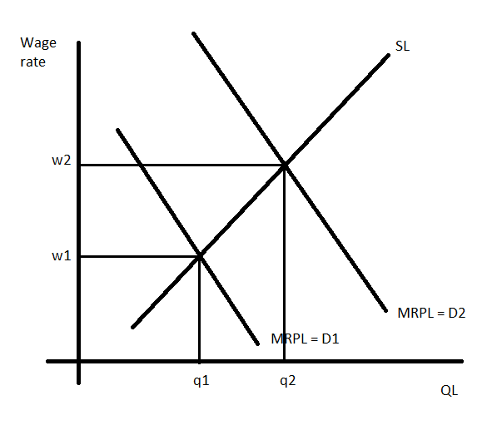
The above diagram therefore shows that females and minority groups may be discriminated against in terms of wages. Based on this explain a range of causes of wage discrimination:
Cause of discrimination | Explanation
The ‘taste model’

Employer ignorance

Explain a range of factors which explain the gender pay gap
Cause of gender pay gap | Explanation
Human capital

Part-time working

Travel patterns

Occupational segregation
Employer discrimination

Explain how the government can intervene to prevent discrimination

Explain a range of reasons why labour may want to migrate to the UK
Cause of migration | Explanation

Is labour migration to the UK beneficial for the UK?
Benefits of migration for UK | Drawbacks of migration for UK

