***Topic 7) The Labour Market: D & S***

***Define the term “derived demand” and explain what the demand for labour is derived from***

|  |
| --- |
|  |

***Define the following key terms:***

|  |  |
| --- | --- |
| ***Key term*** | ***Definition*** |
| Demand for labour |  |
| Marginal revenue product |  |
| Marginal Product (also known as marginal physical product) |  |

***Below are various figures for firms based on a selling price of a good to be £1 each. The cost of each worker is £200 per week. Now complete the table below:***

|  |  |  |  |  |  |  |  |
| --- | --- | --- | --- | --- | --- | --- | --- |
| Number of workers | Total product | Marginal product | Marginal revenue product | Marginal cost | Total revenue | Total cost | profit |
| 1 | 150 | 150 | 150 | 200 | 150 | 200 | -50 |
| 2 | 350 | 200 | 200 | 200 |  | 400 | - |
| 3 | 700 |  |  | 200 |  | 600 | +100 |
| 4 | 950 |  |  | 200 | 950 | 800 |  |
| 5 | 1100 |  |  | 200 |  | 1000 |  |
| 6 | 1250 |  | 150 | 200 |  | 1200 |  |
| 7 | 1300 |  |  | 200 |  | 1400 |  |
| 8 | 1320 |  |  | 200 |  | 1600 |  |

***Use the date above to plot the MC and MRP on the following axis:***

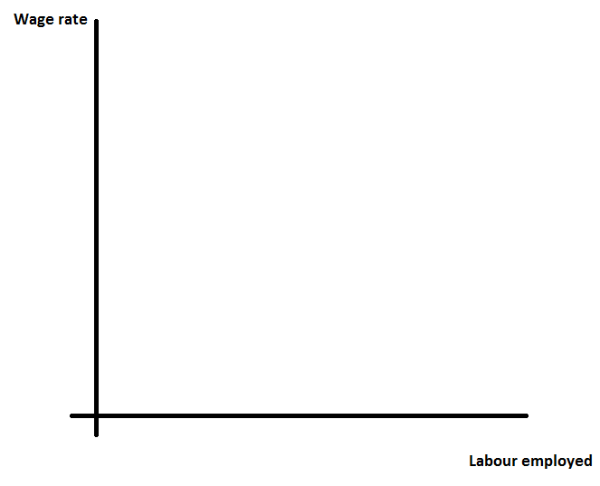

***On your diagram indicate the profit maximising level of employment***

***Explain why this is the profit maximising level of employment***

|  |
| --- |
|  |

***Below shows 3 different labour demand curves:***

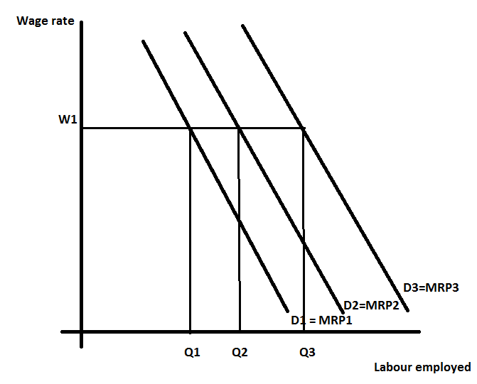

***Identify which factor changing leads to a movement along a labour demand curve***

|  |
| --- |
|  |

***Identify a range of factors which might explain a labour demand curve shifting from W1Q1 to W2Q2***

|  |
| --- |
|  |

***Define the following key terms:***

|  |  |
| --- | --- |
| Key term | Definition |
| Wage elasticity of demand |  |
| Wage inelastic demand |  |
| Wage elastic demand |  |

***Draw a wage inelastic demand curve and a wage elastic demand curve on the axis provided below and then explain a range of causes of each shape:***

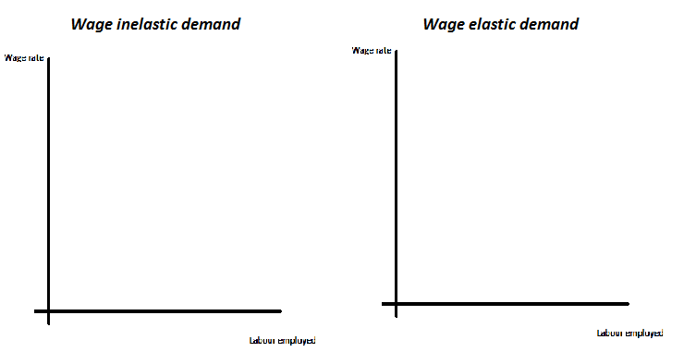

|  |  |
| --- | --- |
| Reasons why demand for labour might be wage inelastic include: | Reasons why demand for labour might be wage elastic include: |
|  |  |

***Define the following key terms:***

|  |  |
| --- | --- |
| Key term | Definition |
| Labour force |  |
| Labour supply |  |

***Below shows two labour supply curves:***

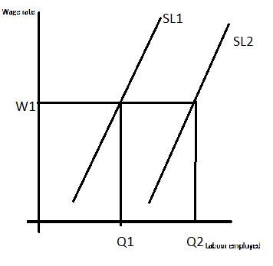

***Explain which factor changing leads to a movement along a labour supply curve***

|  |
| --- |
|  |

***Explain a range of factors which might explain why the labour supply curve might shift from w1q1 to w1q2***

|  |
| --- |
|  |

***Define the following key terms:***

|  |  |
| --- | --- |
| Key term | Definition |
| Wage elasticity of supply |  |
| Wage inelastic supply |  |
| Wage elastic supply |  |

***Below shows a wage inelastic supply of labour curve and a wage elastic supply of labour curve. Below the diagrams explain the reasons for the shape of each labour supply curve:***

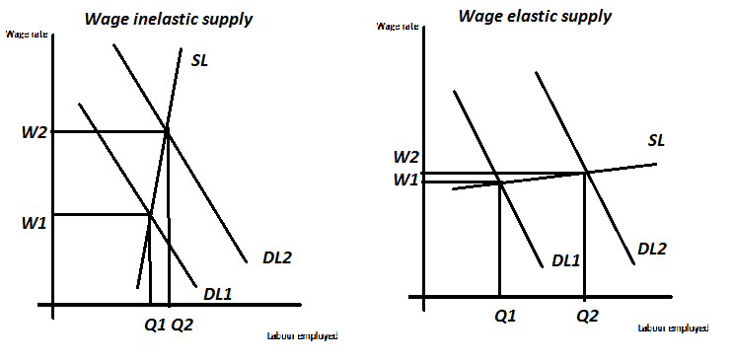

|  |  |
| --- | --- |
| Reasons why supply of labour might be wage inelastic include: | Reasons why supply of labour might be wage elastic include: |
|  |  |

***Explain the following concepts***

|  |  |
| --- | --- |
| Key term | Explanation |
| Work-leisure trade off |  |
| Income effect |  |
| Substitution effect |  |
| Backward-bending labour supply curve |  |

***Draw a backward bending supply curve based on the data below:***

|  |  |
| --- | --- |
| Wage rate (£) per week | Number of hours willing to work i.e. supply of labour for an individual per week |
| 100 | 10 |
| 200 | 20 |
| 300 | 30 |
| 400 | 40 |
| 500 | 45 |
| 600 | 40 |
| 700 | 35 |

