**Distribution of income & wealth**

***Author****:* [*Geoff Riley*](http://www.tutor2u.net/blog/index.php/site/author/3/)***Last updated:*** *Sunday 23 September, 2012*

**Introduction**

**Income and Wealth**

* **Income** is a **flow of factor incomes** such as wages and earnings from work; rent from the ownership of land and interest & dividends from savings and the ownership of shares
* **Wealth** is a **stock of financial and real assets** such as property, savings in bank and building society accounts, ownership of land and rights to private pensions, equities, bonds etc

**Absolute poverty**

Absolute poverty measures the number of people living below a certain income threshold or the number of households unable to afford certain basic goods and services. What we choose to include in a basic acceptable standard of living is naturally open to discussion.

**Relative poverty**

Relative poverty measures the extent to which a household’s financial resources falls below an **average income level**. The official poverty line is drawn at an income of 60% of the median level. Although living standards and real incomes have grown because of higher employment and sustained economic growth, there is little doubt that Britain has become a more unequal society over the last 20-25 years.

**Mean and median income in the UK**

For 2009 the figures (in £s per week) were as follows:

* Median income = £407 per week
* Mean income = £507 per week
* The official poverty line is 60% of the media = £244 per week

6 per cent of individuals live in households with disposable incomes of £1,000 per week or more and this helps to explain why the mean value for household income exceeds the median.

**Income inequality in the United Kingdom**

These figures are drawn from the latest survey on poverty and inequality produced by the Institute for Fiscal Studies ([www.ifs.org.uk](http://www.ifs.org.uk))

* Inequality has remained steady over the course of the recent recession
* Taking the 13-year period of Labour government as a whole, income inequality as measured by the Gini coefficient has increased but at a slower rate than in the 1980s
* Looking over Labour’s 13 years in office, headline rates of relative poverty fell from 19.4% in 1996–97 to 17.1% in 2009–10
* The fraction of children in poverty fell from 26.7% in 1996–97 to 19.7% in 2009–10. This still leaves the rate of child poverty well above the previous government’s target to halve child poverty by 2010
* Using the official relative poverty measure of having an income below 60% of median income, in the UK in 2009–10, there were 13.5 million individuals in relative poverty

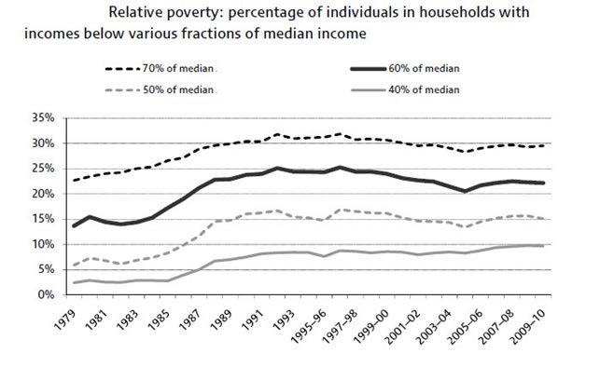

**The Gini Coefficient**

* The Gini coefficient is a commonly-used measure of income inequality that condenses the entire income distribution for a country into a single number between 0 and 1: the higher the number, the greater the degree of income inequality.
* A value of 0 corresponds to the absence of inequality, so that, having adjusted for household size and composition, all individuals have the same household income.
* In contrast, a value of 1 corresponds to inequality in its most extreme form, with a single individual having all the income in the economy
* The value for the Gini-coefficient varies enormously across different countries – the next chart tracks what has happened to the coefficient for the UK since the mid 1990s

**The Lorenz Curve**

The further the Lorenz curve lies below the line of equality, the more unequal is the distribution of income.  
 There are problems with the Lorenz curve – particular if we are inaccurate in our measure of incomes.

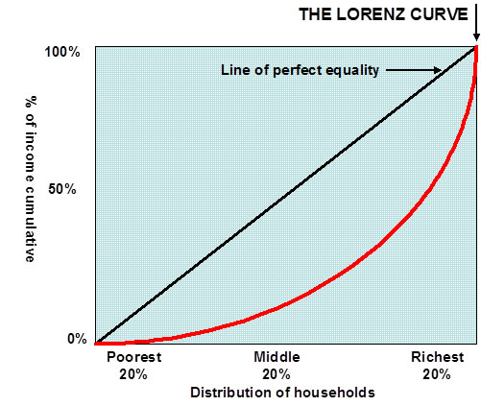

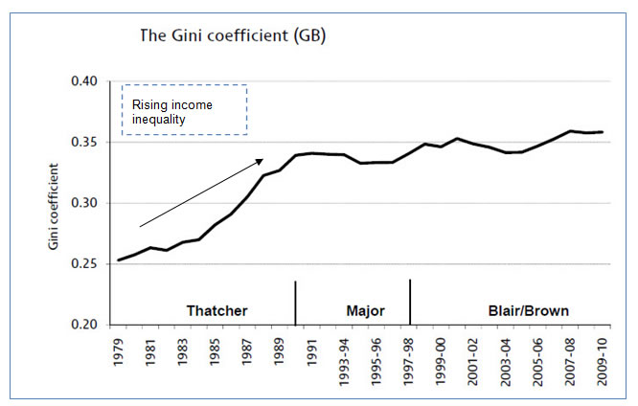

**Gini coefficients for a selection of countries**  
*(Data is taken from the* [*World Bank databank*](http://data.worldbank.org/indicator/SI.POV.GINI)*, most recent published data is used, mainly for 2008-09)*

|  |  |  |  |
| --- | --- | --- | --- |
| Country Name | Gini Value | Country Name | Gini Value |
| Brazil | 53.9 | China | 41.5 |
| Thailand | 53.6 | India | 36.8 |
| Mexico | 51.7 | Indonesia | 36.8 |
| Kenya | 47.7 | Poland | 34.2 |
| Malaysia | 46.2 | Hungary | 31.2 |
| Argentina | 45.8 | Ukraine | 27.5 |
| Uganda | 44.3 | Belarus | 27.2 |
| Russian Federation | 42.3 | ***United Kingdom*** | ***36.1*** |

The gap between lowest and higher income groups can be seen in this chart produced by the UK Statistics Commission:

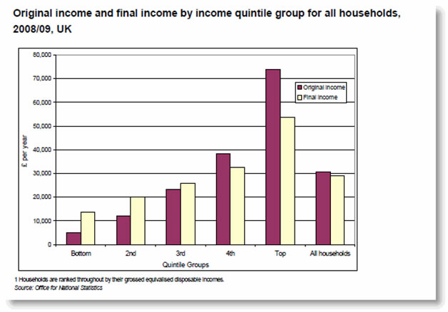

Another way of showing this income data is in the table below – this shows the distribution of disposable income by household income quintile. The data is for 2008-09.

|  |  |  |  |  |  |
| --- | --- | --- | --- | --- | --- |
|  | Bottom Fifth | Next Fifth | Middle Fifth | Next Fifth | Top Fifth |
| % share of disposable income | 7 | 12 | 16 | 22 | 42 |

Inequality of original income (i.e. before taking account of taxes and benefits) has followed a different pattern. It rose fairly steadily throughout the 1980s and has been relatively stable since then. The Gini Coefficient for **disposable income** is lower than for **original income** because of the equalising effects of our progressive tax and benefits system.

**The Distribution of Wealth**

* The distribution of wealth is more unequal than the distribution of income
* Over 90% of marketable wealth is in the hands of just half the population and over a fifth of wealth is concentrated among the richest one per cent of households
* Looking at global inequalities in wealth, a [study from the UN World Development Report published in November 2006](http://news.bbc.co.uk/1/hi/business/6211250.stm) found that the richest 2% of adults in the world own more than half of all wealth.
* According to the report, “Wealth is heavily concentrated in North America, Europe and some countries in the Asia Pacific region, such as Japan and Australia.”

**Explaining the scale of income and wealth inequality in the UK**

|  |  |  |  |
| --- | --- | --- | --- |
| **Proportion of people whose income is below various fractions of median household disposable income** | | | |
|  | < 60% of median income | < 50% of median income |  |
| 1961 | 12.8 | 7.4 |  |
| 1971 | 13.6 | 6.3 |  |
| 1981 | 12.1 | 4.5 |  |
| 1991 | 20.1 | 11.7 |  |
| 2001 | 17.0 | 9.7 |  |
| 2004 | 16.8 | 9.4 |  |
| Source: Social Trends 36 | | | |

There are numerous explanations both for the existence and persistence of a huge divide in incomes and wealth within the UK. Most of them are economic in origin, but some are linked to social change.

A summary is provided below:

**(1) Differences in** [**pay**](http://www.tutor2u.net/blog/index.php/economics/tagged/tag/pay/) **in different jobs and industries**

* High growth industries have enjoyed above average increases in pay and earnings. These include (until recently) financial and business services and information technology. Jobs where labour demand is high and there are shortages of skilled labour tend to offer more generous pay packages for employees.
* The worst paid jobs are still found in lower-skill service sector industries - often where there is little trade union protection and where job insecurity is endemic.
* Globalisation and the rise in the number of high-skill jobs in areas such as finance and technology have boosted demand for skilled labour, enabling individuals with special skills to earn higher wages. In 1973, US chief executives were, on average, paid 26 times the median income. Now they command more than 300 times the median
* There remains a big difference in average hourly wages flowing to groups with different levels of education. This table shows evidence drawn from the UK labour market in 2010.

|  |  |  |
| --- | --- | --- |
|  | **Median hourly pay (£)** | **Pay gap to GCSE** |
| **Degree** | 16.10 | 100% |
| **Higher education** | 12.60 | 56% |
| **A Levels** | 10.00 | 24% |
| **GCSE grades A*-C** | 8.68 | 8% |
| **Other qualifications** | 8.07 | 0% |
| **No qualification** | 6.93 | -14% |
|  |  |  |
| Source: Labour Force Survey, October-December 2010 | | |

**(2) Falling relative incomes of people dependent on state benefits**

* State welfare benefits such as the state pension and unemployment assistance normally rise in line with retail prices (they are index-linked) rather than with earnings.
* Therefore, households dependent on welfare assistance see their **relative incomes** fall over time.
* This is a problem for thousands of pensioner households and also for large families on low incomes since for both groups it is widely recognised that the inflation that they have experienced has been well above the national figure for consumer price inflation.
* Not only have they fallen behind in relative terms – but their real incomes have taken a hit from the sharp surges in food and utility bills over the last two or three years
* In 2008/09, 29 per cent of all pensioners in the UK had no pension provision other than state retirement pension

**(3) The effects of unemployment**

* Unemployment is a key cause of relative poverty
* A serious problem is the increase in the number of households where no one is in paid employment and where a family is dependent on state welfare aid.
* Pockets of **high long-term unemployment** are nearly always associated with an increased risk of [poverty](http://www.tutor2u.net/blog/index.php/economics/tagged/tag/poverty/). London is a good example of this – huge wealth and poverty frequently live cheek by jowl.
* Many adult workers in the labour market have either no skills or limited skills and this affect their employability and expected lifetime earnings and risk of persistent poverty.

|  |  |  |
| --- | --- | --- |
| **UK population, age 22-64, by highest qualification, per cent** | | |
|  | 2010 |  |
| Degree | 25 |  |
| Higher education | 10 |  |
| A Levels | 21 |  |
| GCSE grades A*-C | 20 |  |
| Other qualifications | 12 |  |
| No qualification | 11 |  |
|  |  |  |
| Source: Labour Force Survey, October-December 2010 | | |

**(4) Changes to the tax and benefit system**

* Changes to direct and indirect taxes have contributed to an increase in relative poverty. Income tax rates have fallen over the last two decades
* The top marginal rate of tax fell from 83% in 1979 to 40% in 1988 where it remained for over twenty years – it has since risen back to 50%
* Tax reductions allow people in work to keep a higher proportion of their earned income. The benefits from lower taxes have flowed disproportionately to people on above-average incomes because of a fall in the progressive nature of the UK’s direct tax system.
* There has been a switch towards indirect taxes in recent years including higher rates of value added tax and higher excise duties on petrol, alcohol and cigarettes.
* Some of these indirect taxes have a regressive effect on the distribution of income. A good example of this has been the real-term increase in the level of excise duty on cigarettes and the proposed rises in vehicle excise duty.

**Policy options to change the distribution of income and wealth**

There are many policy options available to a government if it wants to change the final distribution of income and wealth in a country.

* The introduction of a **National** [**Minimum Wage**](http://www.tutor2u.net/blog/index.php/economics/tagged/tag/minimum+wage/) and a series of increases in its value
* **Tax Credits** designed to boost work incentives for low-income households who opt to work
* **Minimum Income Guarantees for Pensioners** and increases in the real value of **Winter Fuel Payments** – designed to alleviate “fuel poverty” among old people
* **Active employment policies** for young people, the long-term unemployed, lone parents and disabled people – a long-term strategy designed to increase employment opportunities
* **Increased spending on training** - UK government expenditure on education and training has doubled in real terms over the last 24 years, from £43 billion in 1987/88 to £87 billion in 2010/11
* **Increased spending on early-years education** - The proportion of children aged under five enrolled in all schools in the UK has increased from 21 per cent in 1970/71 to 62 per cent in 2009/10