***Topic 9) The Distribution of Income & Wealth***

***Define the following key terms***

|  |  |
| --- | --- |
| Key term | Definition |
| Income |  |
| Wealth |  |
| Income inequality |  |
| Wealth inequality |  |

***Below shows a Lorenz Curve. Use this diagram to explain what a Lorenz Curve shows and how it is used to calculate the Gini Coefficient***

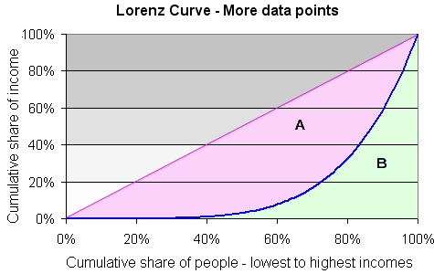

|  |
| --- |
| ***Explanation of Lorenz Curve and Gini Coefficient*** |

***Identify a range of causes of income and wealth inequality***

|  |  |
| --- | --- |
| Cause of income and wealth inequality | Explanation |
|  |  |
|  |  |
|  |  |
|  |  |

Explain the effectiveness of the following policies designed to reduce inequality

|  |  |  |  |
| --- | --- | --- | --- |
| Policy | Explanation | Strengths | Weaknesses |
| National Minimum Wage |  |  |  |
| Working Tax Credits & Child Tax Credit |  |  |  |
| Minimum income for pensioners |  |  |  |
| Tax & Benefit system |  |  |  |