Externalities Overview
We now consider in more detail than at AS level, the economics of externalities and policy approaches to controlling and correcting for market failure caused by the existence of externalities. Environmental economics is now a huge area of the subject.
The economic importance of the environment
The environment plays an absolutely essential role in shaping our economic and social welfare. The environment
- Provides services to consumers in the form of living and recreational spaces and the opportunity to enjoy utility from experiencing natural landscapes and habitats
- It provides us with the natural resources necessary to sustain production and consumption including the basis for renewable and non-renewable sources of energy
- It is a dumping ground for the waste products of our society - be it waste from producers in different industries or from households and consumers
The link between economic activity and our environment is fundamental. We hear constantly about the need for sustainable economic welfare, for growth to take into account the direct and indirect effects on our resources. And increasingly we, as producers and consumers, are affected by many government policies and strategies designed to promote environmental protection and improvement.
What is the commonly accepted definition of sustainability?
Development which meets the needs of the present without compromising the ability of future generations to meet their own needs
World Commission on Environment and Development Our Common Future (1987)
Externalities and the environment – the basics
For environmental economics, one of the most important market failures is caused by negative externalities arising from either production or consumption of goods and services.
A negative externality occurs where a transaction imposes external costs on a third party (not the buyer or seller) who is not compensated by the market. The result is a loss of allocative efficiency and shown by a reduction in economic welfare
Environmental externalities generally arise for three reasons:
- Common resources (not privately owned - e.g. ocean fisheries) – commonly owned resources may lack the protection of property rights and are susceptible to over-exploitation because the marginal cost of extracting the resource for a private economic agent is close to zero. This is known as the “tragedy of the commons”
- Public goods (indivisible common resources - e.g. the air)
- Future generations (sources of externality including carbon emissions – greenhouse effects – contributions to global warming which threatens future sustainability)
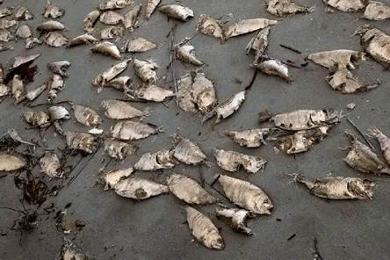
Dead fish on a polluted beach – the external costs of pollution – but who should pay?
In these cases, the private equilibrium of supply and demand is not the same as the social equilibrium which includes all costs. In a completely free market, a producer will have no incentive to control pollution because it is external – i.e. the producer only considers his/her own private costs and benefits. The market failure arising from negative externalities is shown in the diagram below.
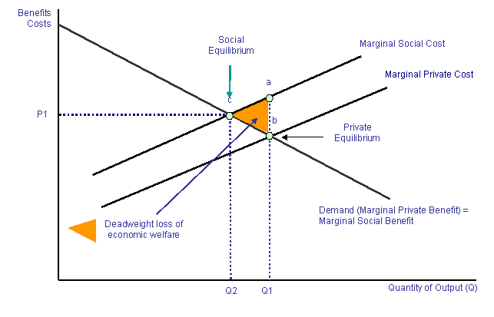
Economists argue that market failures provide a rationale for policy intervention to improve economic efficiency. But since market failures are pervasive, intervention is only justified if the benefits exceed the costs
“The Tragedy of the Commons”
The contribution of each economic agent is minute, but summed over all agents, these actions degrade the resource and may cause severe long term damage
The “tragedy of the commons” is a metaphor used to illustrate the potential conflict between individual self-interests of producers and consumers and the common or public good.
In the original version of the term, the example is used of a stock of common grazing land used by all livestock farmers in a small village. Each farmer keeps adding more livestock to graze on the Commons, because the marginal cost of doing so is zero. But because the commonly-owned resource is then over-exploited, the result is a depletion of the soil and a fall in the value of the resource for all users. The resource may become irretrievably damaged, an example of a public bad.
The root cause of any tragedy of the commons is that when individuals use a public good, they do not bear the entire social cost of their actions. If each seeks to maximize individual benefit, he or she ignores the external costs borne by others. The absence of well defined and legally protected property rights lies at the heart of the problem.
A tragedy of the commons can occur even without complete and permanent destruction of a resource – the term can be used to describe any situation where what was perceived as a renewable resource becomes less valuable because of over-exploitation.
Good examples of the tragedy of the commons:
- Burning of fossil fuels – carbon emissions – contributing to global warming
- Pollution of waterways - creating other externalities for users of waterways further downstream
- Logging of forests – e.g. the long-term impact on the Brazilian rain forest and the effects of illegal logging see http://news.bbc.co.uk/1/hi/business/4842808.stm
- Over-fishing of the oceans – e.g. the current crisis in the EU fishing industry – see http://news.bbc.co.uk/1/hi/sci/tech/4996268.stm
- Fly-tipping of waste products on public land – perhaps a response to the landfill tax?
- E-mail spamming on the internet!
Game theory and the tragedy of the commons
The tragedy of the commons can be linked to the prisoner's dilemma that is a core part of game theory. Individuals within a group have two options: cooperate with the group or defect from the group. Cooperation happens when individuals agree to protect a common resource. Defection happens when an individual decides to use more than his share of a public resource.
Cooperation has the potential to maximize every individual's benefit in the long run (i.e. the 'tragedy' does not happen, the commons are preserved and can be used indefinitely), while defection maximizes an individual's benefit in the short run at the expense of destroying it in the long run. Thus in the case of fish stocks, suppliers need to cooperate over a period of time so that fish stocks can start to rise again. This is the essence of attempts to reform the European Union Common Fisheries Policy.
An alternative to regulation by government is to create a market in property rights in order to control the impact of economic activity on the environment – for example establishing a carbon trading emissions scheme or introduction tradable fishing permits for the EU fishing industry.
The Economics of Waste
The UK government wants more waste being disposed of through incineration rather than dumped in landfill sites. It has restated its strategy and at the top of the waste hierarchy is the desire to reduce the amount of waste created in the first place from the production and consumption of goods and services. The main aim is for the volume of waste to grow less quickly than GDP, in other words to achieve a “de-coupling” of waste generation from rising economic activity. Because waste is normally regarded as a de-merit good creating external costs, there is justification for some form of government intervention in the market to change market prices, alter incentives and, hopefully, cause a change in the behaviour of consumers and producers.
Over two million tonnes of edible food is dumped by retailers in Britain each year, usually into landfill sites
According to data released by DEFRA, less waste in the UK is being land-filled – down from 82% to 72% for municipal waste between 1999 and 2004 and from 50% to 44% for industrial and commercial waste between 1999 and 2003. A successful waste strategy will bring about sizeable increases in waste recycling and composting. Some local authorities have a superb record in raising awareness and interest in recycling products. But in other areas of the UK, recycling rates are abysmally low and well below the levels needed to meet UK and European Union targets. Government policy needs to be more effective in enhancing the incentives for individuals and businesses to recycle more of their waste products.
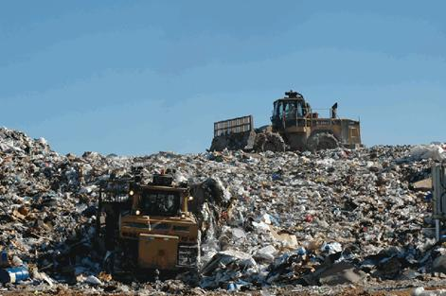
The vast majority of UK household and industrial waste is disposed of in landfill sites
Hierarchy of principles of waste management:
  - Prevention of waste - reduce the amount of waste created in the first place
  - Reuse the product
  - Recycle or compost the product
  - Recover the energy by incinerating
  - Disposal of the product using landfill
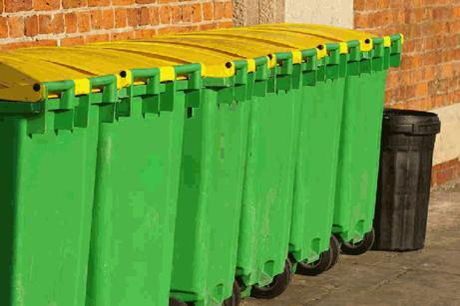
What are the best incentives for households and businesses to reduce the amount of waste created?
Externalities - Government Policy Options
Government intervention to reduce market failure from negative externalities
Traditionally, government policy towards the environment has concentrated in two main areas
- Intervention in the price mechanism – for example through environmental taxes
- Command and control measures – for example direct regulation and legislation
These policies are designed to:
- Achieve a more efficient use of resources
- Promote substitution between resources (e.g. abundant for scarce, renewable for non-renewable)
- Provide incentives for a reduction of pollution emissions or change from harmful to benign
Environmental taxation
An environmental tax is a tax on a good or service which is judged to be detrimental to the environment. It may also be a tax on a factor input used to produce (supply) that final product. The main aim of environmental taxation is to:
- Increase the private cost of producing goods and services so that the producer / consumer is paying for some of the negative externalities that their actions are creating (i.e. the externality is internalised) – this promotes allocative efficiency
- In this way, the government is providing a continuous incentive for the producer / consumer to take the externalities into account, thereby correcting a failure of the signalling function of the price mechanism
- Raise the price of the product so that the level of demand contracts (there is normally a direct link between the level of output / consumption and the total pollution created)
- Reduce output levels towards the estimated social optimum level of production – which contributes to a more sustainable economy in the long term
- Well designed environmental taxes may encourage innovation and the development of new technology which reduces the dependency of an economy on pollution inefficient forms of energy. This can help to promote dynamic efficiency
- Revenue derived from these taxes can be earmarked for lower taxes elsewhere in the economy (e.g. a reduction in employers’ national insurance contributions) or to fund increased government spending on environmental projects / an expansion of provision of public and merit goods. Well designed environmental taxes can provide a source of revenue while correcting an economic distortion
- Inter-generational equity justification: Consider what might happen if the government refuses to introduce some environmental taxes so that current producers and consumers do not pay directly for some of the external costs they create. A refusal to impose tax displaces the environmental costs to future generations (implying a lack of intergenerational equity)
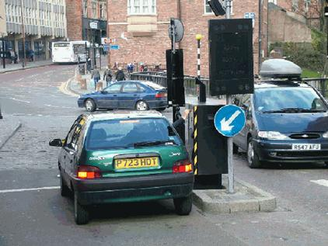
The Durham congestion charge – a means of reducing traffic congestion
Examples of environmental taxes include: petrol duty, vehicle excise duty, the landfill tax, the new carbon tax and the London Congestion Charge. The Irish Government also introduced a tax on plastic bags in a bid to reduce consumption and encourage recycling. The main aim of an environmental tax is to increase the firm’s private marginal cost (PMC) until it equates with the social marginal cost curve (SMC).
Evaluation – problems with environmental taxation
There is a growing body of economists who argue that reliance on environmental taxation is an ineffective way of promoting environmental improvement, indeed that some taxes are prone to government failure. And, that the focus should now switch to alternatives ways of changing the incentives of producers and consumers through the market mechanism. The main criticisms of environmental taxes are discussed below:
- Valuing the environment: There are fundamental problems in setting taxes so that marginal private costs will equate with the marginal social costs. The government cannot accurately value the private benefits and cost of firms let alone put a monetary value on externalities such as the cost to natural habitat, the long-term effects of resource depletion and the value of human life. Frequent adjustments of tax levels may be required and this involves substantial organisational costs
- Consumer welfare effects: Taxes reduce output and raise prices, and this might have an adverse effect on consumer welfare. Producers may be able to pass on the tax to the consumers if the demand for the good is inelastic and, as result, the tax may only have a marginal effect in reducing demand and final output
- Achieving a target quantity of pollution reduction: Taxes do not lend themselves to the government achieving an accurate reduction in total pollution. This is because no government can ever predict how consumers and or producers will respond to higher costs and prices. The elasticity of demand may vary over time.
- Income distribution: Taxes on some de-merit goods (for example cigarettes) may have a regressive effect on low-income consumers and lead to greater inequalities in the distribution of income. Having said this, it should be possible for authorities to develop “smart tariffs or taxes” where account is taken of the impact of pollution taxes on vulnerable households such as low low-income consumers. The current Labour government has reduced the rate of VAT on domestic fuel to the EU minimum rate of 5%, but the government has no plans to introduce a domestic energy tax (which would be an explicit environmental tax) because of the huge numbers of low-income households that currently live in fuel poverty. In the UK, the poorest 10% of households spends 13.2% of income on energy whereas the richest spends 3.5%.
- Employment and investment consequences: If pollution taxes are raised in one country, producers may shift production to countries with lower taxes. This will not reduce global pollution, and may create problems such as structural unemployment and a loss of international competitiveness. Similarly, higher taxation might lead to a decline in profits and a fall in the volume of investment projects that in the long term might have beneficial spill-over effects in reducing the energy intensity of an industry or might lead to innovation which enhance the environment
- More efficient alternatives? It might be more cost effective for governments to switch away from pollution taxation to direct subsidies to encourage greater innovation in designing cleaner production technologies. ‘Eco-tax’ reformers often argue that pollution taxes should be revenue neutral – so for example, an increase in environmental taxation might be accompanied by reductions in employment taxes such as National Insurance Contributions so that the employment consequences of higher taxation are minimised. The impact of green taxes depends crucially on what is done with the revenues. If they are balanced by reducing other taxes through ‘revenue re-cycling’, research suggests that green taxes could result in an overall economic improvement
Alternatives to environmental taxes
An effective use of environmental taxation
Most power stations are surrounded by coal tips or pipes carrying gas. But round the plant that powers the Swedish town of Enköping, some 70 kilometres west of Stockholm, there is willow coppice stretching as far as the eye can see. Enköping is probably the only town in Europe that is powered by bio-fuels. The plant's director, Eddie Johansson, says willow is as economic as coal or gas because Sweden levies a tax on carbon emissions from most power plants. Under the government's rules, he does not have to pay the tax because for every tonne of carbon dioxide that disappears up the stack, the plant's willow trees soak up a tonne from the air as they grow. Hundreds of willow-powered plants could operate across Europe, he says if power companies had similar incentives to cut carbon emissions.
Source: Business Week, September 2005
Carbon Emissions Trading
Emission trading is regarded by many as the future of environmental protection and improvement in the UK, European and international economy. Carbon trading is another form of pollution control that uses the market mechanism to change relative prices and the incentives of producers and consumers. There is also growing interest in the idea of personal carbon trading, the UK government is currently looking at the issue .
Carbon allowances for consumers!
The environment minister, David Milliband has unveiled a radical plan to cut greenhouse gas emissions by charging individuals for the amount of carbon they use. Under the proposals, consumers would carry bank cards that record their personal carbon usage. Those who use more energy - with big cars and foreign holidays - would have to buy more carbon points, while those who consume less - those without cars, or people with solar power - would be able to sell their carbon points. Under the scheme, all UK citizens would be allocated an identical annual carbon allowance, stored as points on an electronic card similar to Air Miles or supermarket loyalty cards. Points would be deducted at point of sale for every purchase of non-renewable energy. People who did not use their full allocation, such as families who do not own a car, would be able to sell their surplus carbon points into a central bank. High energy users could then buy them - motorists who had used their allocation would still be able to buy petrol, with the carbon points drawn from the bank and the cost added to their fuel bills. To reduce total UK emissions, the overall number of points would shrink each year.
Source: Adapted from the Guardian, July 2006
The basics of cap and trade - emissions trading
- A fixed number of emission permits is allocated each year to polluting factories
- Usual denomination: 1 permit = 1 tonne (e.g. of CO2 emissions)
- Total number of permits is the limit on pollution “the cap”
- Annual emissions of each factory must be less than or equal to permit holdings
- Permits can be traded – i.e. “cap and trade”
- Factories which can reduce (abate) pollution for less than the price of a permit can sell spare ones for a profit
- Factories which find it more expensive to reduce pollution can buy extra permits instead
- Gradually the supply of permits is reduced – the market price rises. This gives firms who find it expensive to cut pollution, more of an incentive to seek new technologies / process that will reduce their pollution emissions
A marketable pollution permit gives a business the right to emit a given volume of waste or pollution into the environment. Ideally, the number of permits that are issued corresponds with the total level of pollution that is admissible at the social optimum level of output i.e. where the MSB = MSC. Once this has been determined the permits are issued by auction and firms that pollute the environment can bid for them and then buy and sell them amongst themselves.
Pollution permits should, in theory, give firms an incentive to control pollution emissions for less than it would cost to buy permits, and there is evidence from “cap and trade” pollution permit schemes in the UK and the United States that the costs of monitoring pollution reduction and administration of the permits system is smaller than when an industry is subject to direct regulation. In the United States cap and trade scheme, it was found that many high-polluting businesses invested in fitting new pollution control equipment (e.g. Flue Gas Desulphurisation) and other polluters switched from high to low sulphur coal.
Consequently the use of marketable permits allows the cost of pollution control to be minimised. Another advantage is that the revenue from a traded pollution permits scheme can be re-cycled into other schemes for environmental improvement.
Incentives matter – create a market in the “right to pollute” - The basic idea behind traded pollution permits is to through the incentive to cut pollution directly to the producers themselves. Companies can then make their own decisions about the costs and benefits to them of particular routes to emission reductions. In other words, market forces are brought to bear on the issue of pollution and potential market failure.
Emission trading is likely to be most effective when:
- There is an easily measurable pollutant
- The government sets a clearly defined and stable emissions target
- There are a large number of participant firms, with companies sufficiently sophisticated to deal with the technicalities of trading at auction
- Wide variation in costs of reducing pollution so that trading of surplus permits can take place
- The transactions costs of trading permits are low and there is clear pollution data availability at the start and during trading
- Strict enforcement of permits (i.e. a high compliance rate among participating businesses)
Kyoto
Emission trading was a key feature of the Kyoto Protocol as a strategy to address some of the threats posed by climate change in 1997. Kyoto allows trading of permits for carbon dioxide between industrialised countries but the United States withdrew from the agreement in 2001 and since the USA represents 32% of emissions amongst developed countries with emission targets, the absence of the USA from an embryonic trading system will seriously reduce demand for permits and therefore drive down their price and effectiveness.
Pollution regulation
Instead of relying on intervention in the market mechanism by using taxation, subsidies or pollution permits, the government and its appointed agencies can regulate the level of output and pollution in a market. In theory, the government could set a quota so that output is set at the social optimum. More frequently, minimum or environmental / emission standards are widespread in many industries. This requires regulatory bodies to monitor (inspect) and fine firms that do not meet the standards set for water and air quality.
The 1989 Environmental Protection Act for example set standards on emissions for firms that carried out chemical processes, waste incineration and oil refining. There will be a ban on smoking on public places in England from the summer of 2007. A ban came into force in Scotland in March 2006.
Compliance with environmental regulations can be very costly to enforce and it may be impossible to monitor all firms accurately because of imperfect information. Regulation also does not bring in any direct tax revenue flows that can be used to fund environmental improvement schemes or compensate those who have been negatively affected by pollution.
Suggestions for further reading on carbon emissions trading
  - Carbon trading, what price a pollution solution? (Green Biz)
  - Carbon trading’s real colours (BBC)
  - Power tool (Guardian)
  - Questions are raised over carbon trading (Guardian)
  - Scale of industry’s impact on the environment (Guardian)
Airlines and environmental policy
Over the past 20 years, there has been huge growth in the airline industry. The number of passenger kilometres has risen from 125 billion worldwide in 1990 to 260 billion in 2000, while air freight grew even faster, at 9% per year. In 1970, British airports were used by 32 million people. In 2004, the figure was 216 million. In 2030, according to government forecasts, it will be around 500 million.
Several factors have contributed to rising demand for airline travel
The emergence of low-cost flying, such as EasyJet and Ryanair which have brought prices down allowing lower-income families to fly and creating a new effective demand for flying
New technologies have also made long-haul flights with flagship-carriers, such as BA, cheaper and more enjoyable
Increased demand for business air travel
Aviation creates external costs. The main external cost of flying is the damage to the environment. It is estimated that one return flight to Florida produces as much carbon dioxide as a year’s motoring, while a return flight to Australia the same amount as 3 cars in one year. And flying from London to Edinburgh produces 8 times as much carbon dioxide as taking the train. Aviation currently contributes 5% to the UK’s carbon dioxide emissions. With air travel growing at 3-5%, it is expected that planes will contribute 15% to the UK’s carbon dioxide emissions in the next ten years
For some time, there has been a debate over the merits and de-merits of introducing an aviation tax on airlines. Is this the best way of controlling the environmental damage created by the rapid expansion of the UK and European airline industry? Or will it simply create more problems and damage the competitiveness of the European airline sector? Are there better more effective ways of reducing pollution? For example bringing the airlines into the newly established EU carbon emissions trading scheme?

