**Market failure - externalities**

***Author****:* [*Geoff Riley*](http://www.tutor2u.net/blog/index.php/site/author/3/)***Last updated:*** *Sunday 23 September, 2012*

**Introduction**

Externalities are common everywhere in everyday life but will the market – left to its own devices - take these externalities into account? If not, then [market failure](http://www.tutor2u.net/blog/index.php/economics/C19/) can occur and there is a justification for some form of [government intervention](http://www.tutor2u.net/blog/index.php/economics/C185/).

**Economic importance of the environment**

The [environment](http://www.tutor2u.net/blog/index.php/economics/tagged/tag/environment/) plays an essential role in shaping our economic and social welfare. The environment

* **Provides services to consumers** in the form of living and recreational spaces and the opportunity to enjoy utility from experiencing natural landscapes and habitats.
* It provides us with the **natural resources necessary to sustain production and consumption** including the basis for renewable and non-renewable sources of energy.
* **It is a dumping ground for the waste products of our society** - be it waste from producers or from households and consumers.

The link between economic activity and our environment is fundamental. We hear constantly about the need for **sustainable welfare,** for growth to take into account the direct and indirect effects on our resources. And increasingly we, as producers and consumers, are affected by government policies and strategies designed to promote environmental protection and improvement.

**Sustainable development** is that which meets the needs of the present without compromising the ability of future generations to meet their own needs.

**Externalities and the environment – the basics**

For **environmental economics**, one of the most important market failures is caused by **negative externalities** arising from production and/or consumption of goods and services.

Externalities are **third party effects** arising from production and consumption of goods and services for which **no appropriate compensation is paid**.

**Externalities occur outside of the market** i.e. they affect people not directly involved in the production and/or consumption of a good or service. They are also known as **spill-over effects**.

One of the major problems facing the environment is that **common resources** such as fish stocks and grazing land are not privately owned – commonly owned resources may lack the protection of property rights and are susceptible to over-exploitation because the marginal cost of extracting the resource for a private agent is close to zero. This is known as the **“**[**tragedy of the commons**](http://www.tutor2u.net/blog/index.php/economics/tagged/tag/tragedy+of+commons/)**.”**

When there are environmental externalities, the **private equilibrium price and quantity determined by the interaction of market supply and demand** is not the same as the social equilibrium which includes all internal and external costs.

In a free market, a producer will have little direct incentive to control pollution because it is external – i.e. the profit-maximising supplier considers only his/her own private costs and benefits.

The market failure arising from negative externalities is shown in the diagram below. The area labelled ABC is the deadweight loss of welfare due to output being above the social optimum. At output levels beyond Q2, the marginal social cost exceeds the marginal social benefit causing overall welfare to drop.

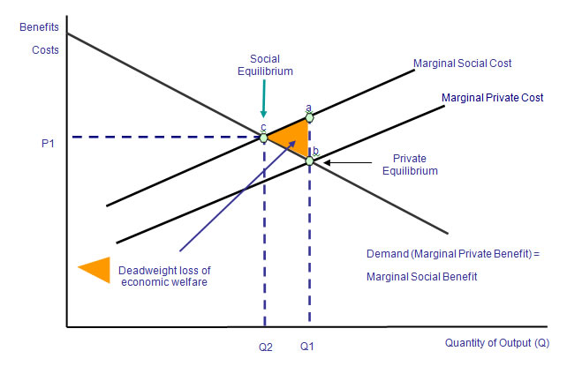

Economists argue that **market failures provide a clear rationale for policy intervention** to improve efficiency. But since market failures are pervasive, **intervention is only justified if the benefits exceed the costs.** As we shall see, reducing pollution is rarely, if ever, a cost-free process.

**“The Tragedy of the Commons”**

The contribution of each economic agent is minute, but summed over all agents, these actions degrade the resource and may cause severe long term damage

The “[**tragedy of the commons**](http://www.tutor2u.net/blog/index.php/economics/tagged/tag/tragedy+of+commons/)” is a metaphor used to illustrate the potential conflict between individual **self-interest** of producers and consumers versus the **common or public good**.

In the original version of the term, the example is used of a **stock of common grazing land** used by all livestock farmers in a small village. Each farmer keeps adding more livestock to graze on the commons, because the **marginal cost** of doing so is zero. But because the commonly owned resource is thus over-exploited, the result is a [depletion](http://www.tutor2u.net/blog/index.php/economics/tagged/tag/depletion/) of the soil and a fall in the value of the resource for all users.

The resource may become irretrievably damaged, an example of a **public bad**.

The root cause of any tragedy of the commons is that when individuals use a **public good**, they do not bear the entire **social cost** of their actions. If each seeks to maximize individual benefit, he or she ignores the external costs borne by others. The absence of well-defined and legally-protected property rights lies at the heart of the problem.

A tragedy of the commons can occur even without complete and permanent destruction of a resource – the term can be used to describe any situation where what was perceived as a renewable resource becomes less valuable because of over-exploitation.

Good examples of the tragedy of the commons

* Burning of fossil fuels – carbon [emissions](http://www.tutor2u.net/blog/index.php/economics/tagged/tag/emissions/) – contributing to [global warming](http://business.guardian.co.uk/Guardian/flash/0,,1267004,00.html)
* [Pollution of waterways](http://www.britishwaterways.co.uk/home/index.html)  - creating other externalities for users of waterways further downstream
* Logging of forests – e.g. the [long-term impact on the Brazilian rain forest](http://news.bbc.co.uk/1/hi/business/4842808.stm) effects of illegal logging
* Over-fishing of the oceans – e.g. the [current crisis in the EU fishing industry](http://news.bbc.co.uk/1/hi/sci/tech/4996268.stm)
* [Fly-tipping of waste products on public land](http://news.bbc.co.uk/1/hi/uk/5230100.stm)

**Game theory and the tragedy of the commons**

The [**tragedy of the commons**](http://www.tutor2u.net/blog/index.php/economics/tagged/tag/tragedy+of+commons/) can be linked to the **prisoner's dilemma** that is an important part of **game theory**.

Individuals within a group have two options: **co-operate** with the group or **defect** from the group. Cooperation happens when individuals agree to protect a common resource. Defection happens when an individual decides to use more than his share of a public resource.

Cooperation has the potential to maximize every individual's benefit in the long run as the commons are preserved and can be used indefinitely, while defection maximizes an individual's benefit in the short run at the expense of destroying it in the long run.

Thus in the case of **fish stocks**, suppliers need to cooperate over a period of time so that fish stocks can start to rise again. This is the essence of attempts to reform the [European Union Common Fisheries Polic](http://ec.europa.eu/comm/dgs/fisheries/index_en.htm)y.

An alternative to regulation and taxation by government is to create a **market in property rights** in order to control the impact of economic activity on the environment – for example establishing a [**carbon trading**](http://www.tutor2u.net/blog/index.php/economics/tagged/tag/carbon_trading/) **emissions scheme** or introduction tradable fishing permits for the EU fishing industry.

**The Economics of Waste**

Waste is an inevitable by-product of production and consumption. But the economics of waste is now a huge economic as well as social issue. The UK government wants more waste being disposed of through [**incineration**](http://news.bbc.co.uk/1/hi/sci/tech/4622484.stm) rather than **dumped in landfill sites**. It has [restated its strategy](http://news.bbc.co.uk/1/hi/sci/tech/4708758.stm) and at the top of the waste hierarchy is the aim of reducing how much waste is created in the first place and thereby achieve a “**de-coupling**” of waste generation from rising economic activity. Because waste is normally regarded as a **de-merit good** creating **external costs**, there is justification for some form of government intervention to change market prices, alter incentives and cause a change in the behaviour of consumers and producers.

Government policy needs to be more effective in [enhancing the incentives for individuals and businesses](http://www.letsrecycle.com/) to recycle more of their waste products.  
  
**Hierarchy of principles of waste management:**

* + **Prevention of waste** - reduce the amount of waste created in the first place
  + **Reuse** the product
  + **Recycle or compost** the product
  + **Recover the energy** by incinerating
  + **Disposal** of the product using landfill