**Public Goods**

***Author****:* [*Geoff Riley*](http://www.tutor2u.net/blog/index.php/site/author/3/)***Last updated:*** *Sunday 23 September, 2012*

*When the market fails to provide certain goods and services, there is a clear case for government intervention.*

**The nature of public goods**

Public goods are services which must be provided collectively for two main reasons:

* **Non-excludability** - the goods cannot be confined to those who have paid for it
* **Non-rivalry in consumption** - the consumption of one individual does not reduce the availability of goods to others

Examples of pure public goods include flood control systems, street lighting and national defence. A flood control system, such as the Thames Barrier, cannot be confined to those who have paid for the service. Also, the consumption of the service by one household will not reduce its availability to others. If left to the free market mechanism, no public goods would be provided and, as a result, there would be a clear market failure. No individual consumer would pay for a product that could be consumed for free if another household decided to purchase it.

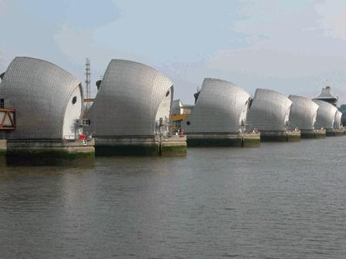  
*The benefits of the Thames Barrier cannot be confined only to those people who have paid for it*

**Quasi-public goods:** These are products that are essentially public in nature, but do not exhibit fully the features of non-excludability and non-rivalry. The road network in the UK is currently available to all, but could be made excludable via a system of electronic road pricing. There is also non-rivalry in consumption, but only up to an extent. Once the road becomes congested there is rivalry in consumption.

**Environmental public goods**: An example of an environmental public good is public open space, which nobody would provide on their own, even though everybody benefits from it being available. Street lighting is another example of a public good.

**The Air-Waves – a Quasi Public Good**  
The airwaves are essentially owned by the government of a particular country. Do they count as a pure public good? Normally the answer would be yes. One person’s use of the airwaves rarely reduces the extent to which other people can benefit from utilising them. But when demand for mobile phone services is high at peak times, the airwaves become crowded and access to the networks provided by the main mobile phone companies can become slow. In this sense the airwaves can be treated a crowded non-pure public good.   
The government controls the issue of licences needed to operate mobile phone services using the airwaves in the UK. In 2000, they auctioned off five licences for 3rd generation mobile phone services and raised £22 billion in doing so. The government was using the auction process to ration the airwaves through a licence system. Although the government has monopoly control in the sense that it controls the issue of licences, it did not set the market price. This was determined by the auction process, and the fact that at the end of a bidding war, the major mobile phone companies were prepared to pay such a high price for a licence to allow them to operate in the market, is evidence of the private benefit (or anticipated future profit) that the companies expected to make from selling 3rd generation contracts to customers.   
The fact that these telecoms companies may have greatly misjudged the actual market demand for third generation mobile phone services is not the result of the auction process itself. The government decided that the income from the sale of these licences would be used to repay a slice of the national debt, providing a bonus for current and future generations in terms of reducing the annual interest payments on government debt.

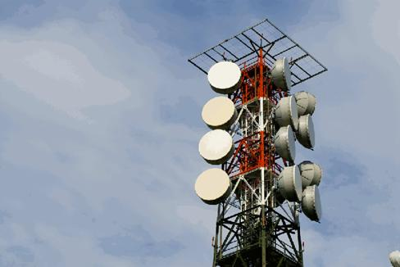  
*An example of a quasi public good - the air-waves can become congested*

**Finding an Equilibrium Allocation of Public Goods that Maximises Social Welfare**

Finding the socially efficient level provision of public goods is a hugely difficult process. First we must seek a valuation of the willingness and ability of consumers to pay for public goods which involves estimating the individual demand curves for each consumer and then aggregating to find the “market demand curve” – a reflection of the social marginal benefit (or valuation) that consumers place on each extra unit of a public good that is made available.   
In the diagram below we consider a non-pure public good whose marginal cost of supply does rise gently as output is increased. If the market fails to provide a sufficient quantity of a public good, then there is a loss of economic (social) welfare.

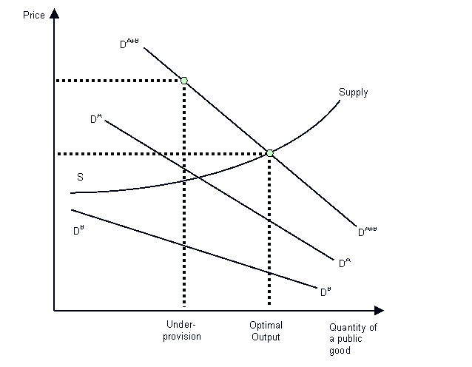

**Case Study: The BBC as a public good**

Broadcasting is a good example of a public good. Let us remind ourselves of the three main characteristics of a public good.

Firstly it is non-rival, meaning that the consumption of a public good or service by one individual does not preclude consumption by another individual. Secondly, consumption is non-excludable. This means that consumption by one individual makes it impossible to exclude any other individual from having the opportunity to consume. Effectively the marginal cost of providing a pure public good to an extra user is zero, and this implies that, in order to achieve allocative efficiency, the charge for the product should be zero. Of course, in this situation, private sector businesses are unlikely to consider providing pure public goods because they will not be able to make any profit at a zero price, and many consumers can take a free ride on such goods because of non-excludability. The provision of pure public goods is therefore a cause of market failure. Left to the free market, public goods are under-provided and under-consumed leading to a loss of social welfare.

Traditional analogue broadcasting differs from encrypted digital broadcasting in the sense that digital broadcasters can now exclude non-payers using set-top boxes. But even when Britain moves fully to digital when the analogue signal is turned off in a few years, the broadcasting services will continue to be completely non-rival and it is this that really matters in the context of the services that the BBC provides. One extra person consuming programmes on BBC1 or BBC2 has no effect at all on the ability of people to consume other services provided by the BBC.

**Paying for a public good - the licence fee debate**

At the moment, around 23 million households in Britain pay an [annual licence fee](http://www.bbc.co.uk/info/licencefee). All of these people are stakeholders in the debate about the future funding of the BBC and the vast majority use one or more [BBC services](http://www.bbc.co.uk/info) at least once a week. The fee is a means of providing collective payment for a public good. We know that there are fee-dodgers who try to take a free-ride by avoiding payment, but there are well established although costly means to enforce the licence fee and take non-payers to court.

According to research undertaken by the BBC as part of the Charter Review, on rough estimates, about 17 million households value BBC television, radio and internet services at more than the current licence fee of £122. These are gainers from the existence of the BBC. In contrast, the study finds that 6 million people value the BBC at less than the current licence fee. These are losers – they are paying more than the utility that they get and many such people may resent having to pay the licence fee when they have paid for their [BSkyB](http://en.wikipedia.org/wiki/Bskyb) subscription and have already deserted the BBC for other digital or commercial channels. The BBC study estimates that the net consumer surplus created by the BBC is well over £2bn/year, or ¼% of GDP.

The most likely groups to think the licence fee represents good value for money for their household are those aged over 60 and those in the higher AB social groups. Groups more likely to think the fee represents poor value for money are those with multi-channel television access, people aged 31-45, people in the C2DEs social groups and younger people of Black or Asian origin. People in C2DE social groups are far more likely to have an income below the median, and therefore the question of raising the licence fee becomes important because a sharp rise in its level would affect people’s ability to pay.

|  |  |  |
| --- | --- | --- |
| **Television** | **Radio** | **Other** |
| BBC 1 | Radio 1 | BBC Online |
| BBC 2 | Radio 2 | World Service |
| BBC 3 | Radio 3 | BBC Scotland |
| BBC 4 | Radio 4 | BBC Northern Ireland |
| Cbeebies | Radio Five Live | BBC Wales |
| CBBC | Five Live Extra | BBC English Regions |
| BBC News 24 | 1Xtra |  |
| BBC Parliament | 6 Music |  |
|  | BBC 7 |  |
|  | Asian Network |  |
|  | 6 Nations services |  |
|  | 40 local and regional services |  |

For millions of people, the value that they derive from the BBC’s output does exceed the price they currently have to pay via the licence fee. Would they be happy to pay a significantly higher fee in the future? Much would depend on the quality and range of broadcasting that the BBC is able to deliver. Assuming a constant range, reliability and quality of services, a large rise in the BBC licence fee would reduce total consumer surplus. The BBC study estimates that if the fee was raised by forty per cent from £122 to £170, up to four million people would no longer value BBC services as much as the higher compulsory fee, consumer surplus would be reduced and the BBC’s services might end up being under-consumed.

This, in a nutshell, is the argument against the introduction of a subscription-based system for funding the BBC. It would exclude several million people from consuming their services and would probably result in a net loss of social welfare.

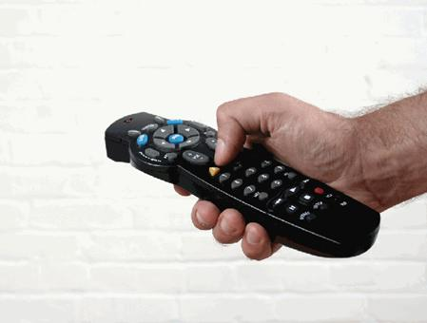

*What is the best way to finance broadcasting? Should the licence fee remain compulsory?*

**Criticisms of the licence fee**

Opponents of the licence fee argue that

1. It is a **regressive form of taxation** – everyone pays the same flat charge, regardless of their disposable income, the number of televisions they own or the extent to which they watch television in general and BBC services in particular
2. As fewer people watch the BBC, the case for a licence fee diminishes. Indeed as technology develops, it become even harder to sustain a compulsory licence fee when people have moved predominantly to **alternative sources of information** through the internet, digital channels, broadband and their mobile phones
3. The **costs of collection and evasion are high** including £150 million per year chasing licence-fee evaders

**What are the alternatives for funding the BBC?**

* Moving to a **subscription base system** (technology may allow this in the future).
* Allowing advertising and sponsorship of programmes similar to the ITV model.
* Greater emphasis on **selling BBC programmes overseas** through [BBC Worldwide](http://en.wikipedia.org/wiki/BBC_Worldwide) and sales of DVDs to generate increased revenue for the BBC.
* Funding the BBC entirely through **direct taxation** and scrapping the licence fee.
* A tax on the revenues of other commercial broadcasters to part-fund the BBC’s services – reflecting the public service nature of much of the BBC’s output.

Of these alternatives, introducing advertising is least preferred among people surveyed. A sizeable majority of viewers (over sixty per cent according to a recent MORI poll) regard advertising as an intrusion to their enjoyment of programmes, and few think that the BBC should move to this form of finance. And there are worries that the total size of the TV advertising market is not large enough to absorb the entry of the BBC as a supplier of advertising slots. It might well damage the financial viability of ITV for example. In any case, advancing technology now allows viewers to skip advertising when they have pre-recorded programmes.

On the whole, there is a preference for keeping the licence fee ([a system of funding used in many other countries](http://en.wikipedia.org/wiki/Television_licence)) although there are concerns among older groups about their ability to pay for it. But without a sizeable increase in its value, there is little doubt that BBC revenues will soon be overtaken permanently by Sky and this will damage the BBC’s ability to bid for live television events including the rights for sports such as soccer, cricket and golf.

**Public Goods and the Free Rider Problem**

Consumers have an incentive to not reveal their willingness and ability to pay for public goods if they believe that they will be expected or required to contribute to financing the public good accordingly by the government. After all, if the public good is supplied, it will be available to them just as it would be to anyone else because pure public goods are non-excludable.  This is the essence of the “free rider problem”: the incentive which consumers have to avoid contributing to financing public goods in proportion to their valuation of such good.

Good examples to use include TV licence dodgers and people who choose to evade the Council Tax but who still receive local authority services. Another example might be a group of residents in a block of flats who all stand to benefit from the refurbishment of an adjacent playground or better lighting and security systems, but who individually might try to avoid payment and benefit once the improved amenities are in place.

Given the nature of the free rider problem, public goods are often financed through some form of enforcement, notably the compulsory nature of the [TV licence fee](http://news.bbc.co.uk/1/hi/entertainment/4641006.stm), management fees for residents living in blocks of accommodation or the signing of international treaties on the environment.  .