***Topic 10) Government Intervention in the Market***

***Use pages 156-182 from your associated study pack to complete the following:***

***Define the term ‘market failure’***

|  |
| --- |
|  |

***Explain the following types of market failure***

|  |  |
| --- | --- |
| Market failure | Explanation |
| Negative externalities |  |
| Positive externalities |  |
| Information failures |  |
| Public goods |  |
| Monopolies |  |
| Factor immobility e.g. immobility of labour |  |
| Equity issues |  |

***Define the following key terms***

|  |  |
| --- | --- |
| Key term | Definition |
| Productive inefficiency |  |
| Allocative inefficiency |  |

***Briefly explain the following types of government intervention***

|  |  |
| --- | --- |
| Government intervention | Explanation |
| Government legislation and regulation |  |
| Direct state provision |  |
| Fiscal policy intervention |  |
| Closing information gap |  |

***Define the key term government failure***

|  |
| --- |
|  |

***Outline a range of examples of government failure***

|  |
| --- |
|  |

***Explain using a diagram environmental market failure (negative externalities – p177+)***

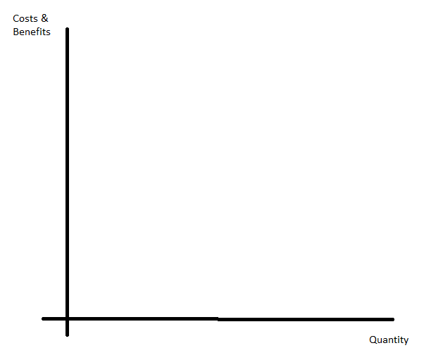

|  |
| --- |
| ***Explanation*** |

***Explain the key term ‘tragedy of the commons’***

|  |
| --- |
|  |

***Explain the effectiveness of a range of government interventions designed to correct environmental market failure***

|  |  |  |  |
| --- | --- | --- | --- |
| Intervention | Explanation | Strengths | Weaknesses |
| Carbon emissions trading |  |  |  |
| Pollution regulating |  |  |  |

***What is a cost-benefit analysis?***

|  |
| --- |
|  |

***Explain the stages used to produce a CBA***

|  |
| --- |
|  |

***Outline a range of weaknesses of CBA as a tool***

|  |  |
| --- | --- |
| Weaknesses of CBA | Explanation |
| Problems of attaching values to costs & benefits] |  |
| CBA may not cover everyone affected i.e. all 3rd parties |  |
| Discounting the future |  |
| Distributional consequences |  |

***Summarise the CBA completed for Terminal 5 at Heathrow Airport***

|  |  |
| --- | --- |
| ***Benefits*** | ***Costs*** |
|  |  |